JOOMLA/JOPENSIM UPDATE
IMPORTANT: Joomla/jOpensim V3 (up to Joomla 3.9.23) is deprecated and no longer supported. It has been replaced by Joomla + JOpensim V4, which is a NEW major version, not an in-place upgrade - do not expect the old Joomla updater or the old V3 install to carry forward. If you still have a V3 site installed under OutworldzFiles\Apache\htdocs\JOpensim, back it up (Akeeba Backup) and remove that folder before installing V4; DreamGrid's Install button will refuse to run while that folder is non-empty. If you also have jOpenSim PayPal in use, you will need to update this component as well.

How to Update jOpensim (within V4):
These steps update the JOpensim extension package on top of an existing Joomla + JOpensim V4 install (Setup->Settings->Install CMS->Joomla->Install). They do not apply to a V3 site - a V3 site must be replaced by a fresh V4 install instead, per the note above.
In DreamGrid, go to Setup->Settings, click Install CMS, and then click Joomla.
Press the [Update] button to update to the latest jOpensim. This will take you to this screen:
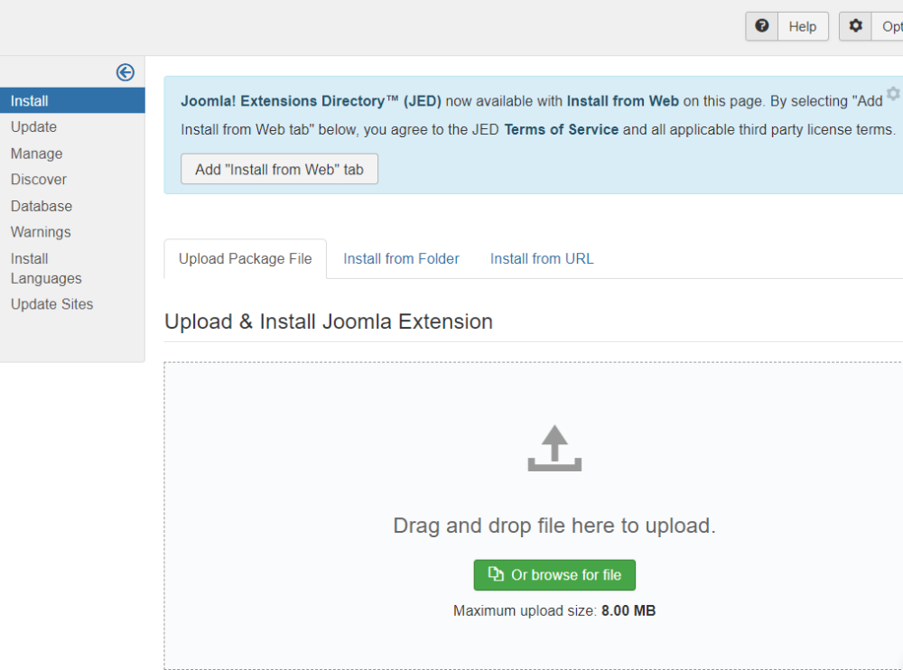

Click the big green “Or Browse for file” and navigate to the OutworldzFiles\jOpensim_Files\ folder. Select the JOpen*.zip file found there (e.g. JOpensim.0.4.0.4_RC7.zip) and click Ok. This will update your jOpensim install to the latest V4 package. DreamGrid no longer hardcodes this filename, since the maintainer replaces it with newer package versions over time - always pick whichever single JOpen*.zip file is present.

